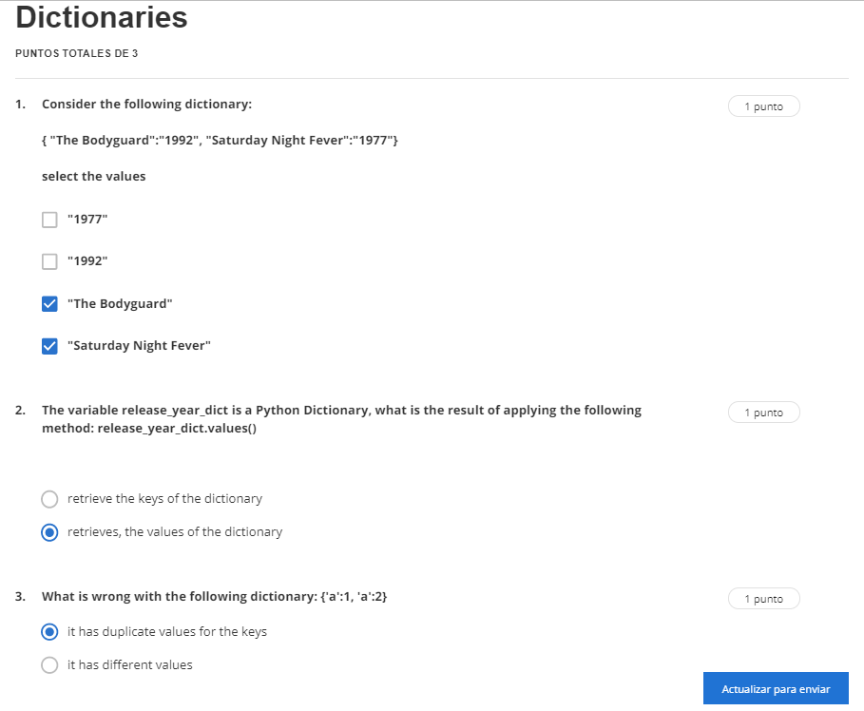

2. ans:retrieve the keys of the dictionary